**Handsons 1**

**1. Configured notedpad++ as the text editor.**

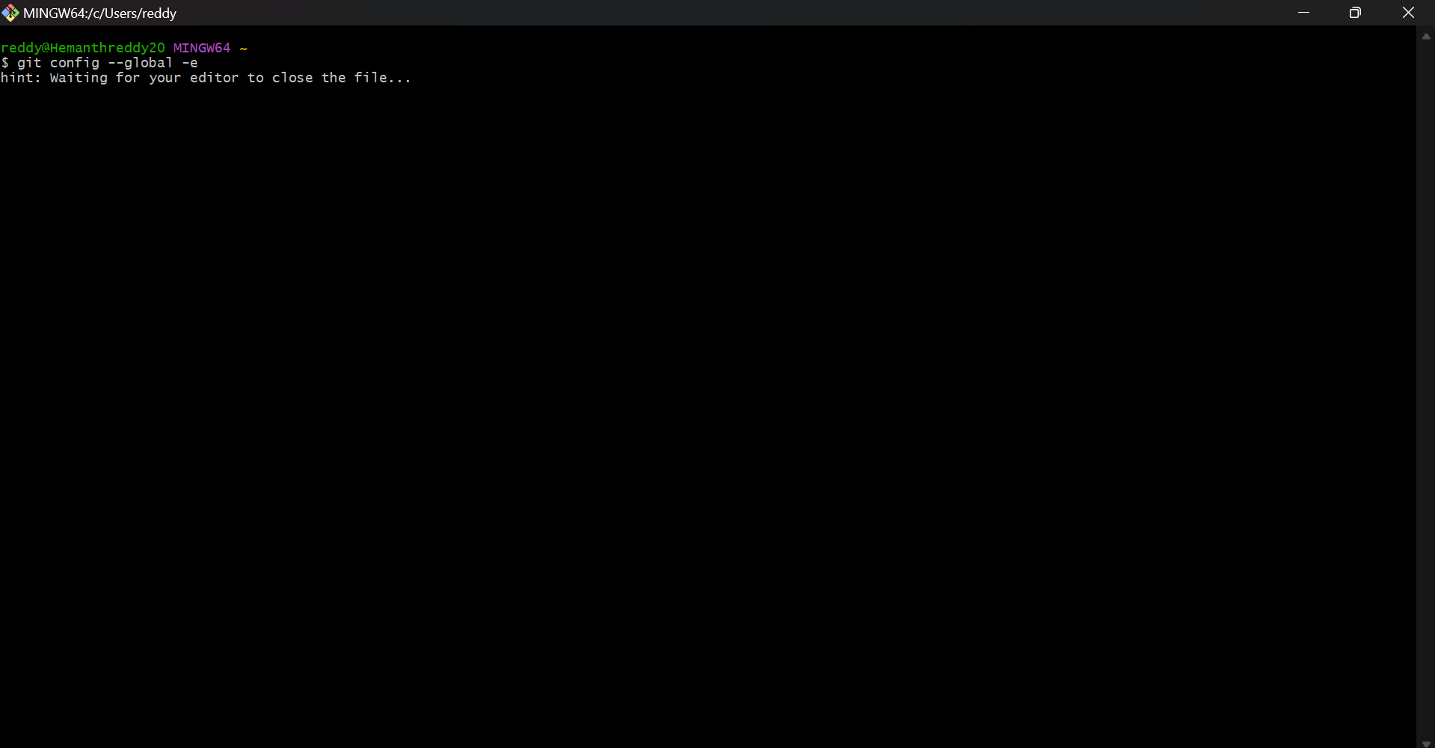

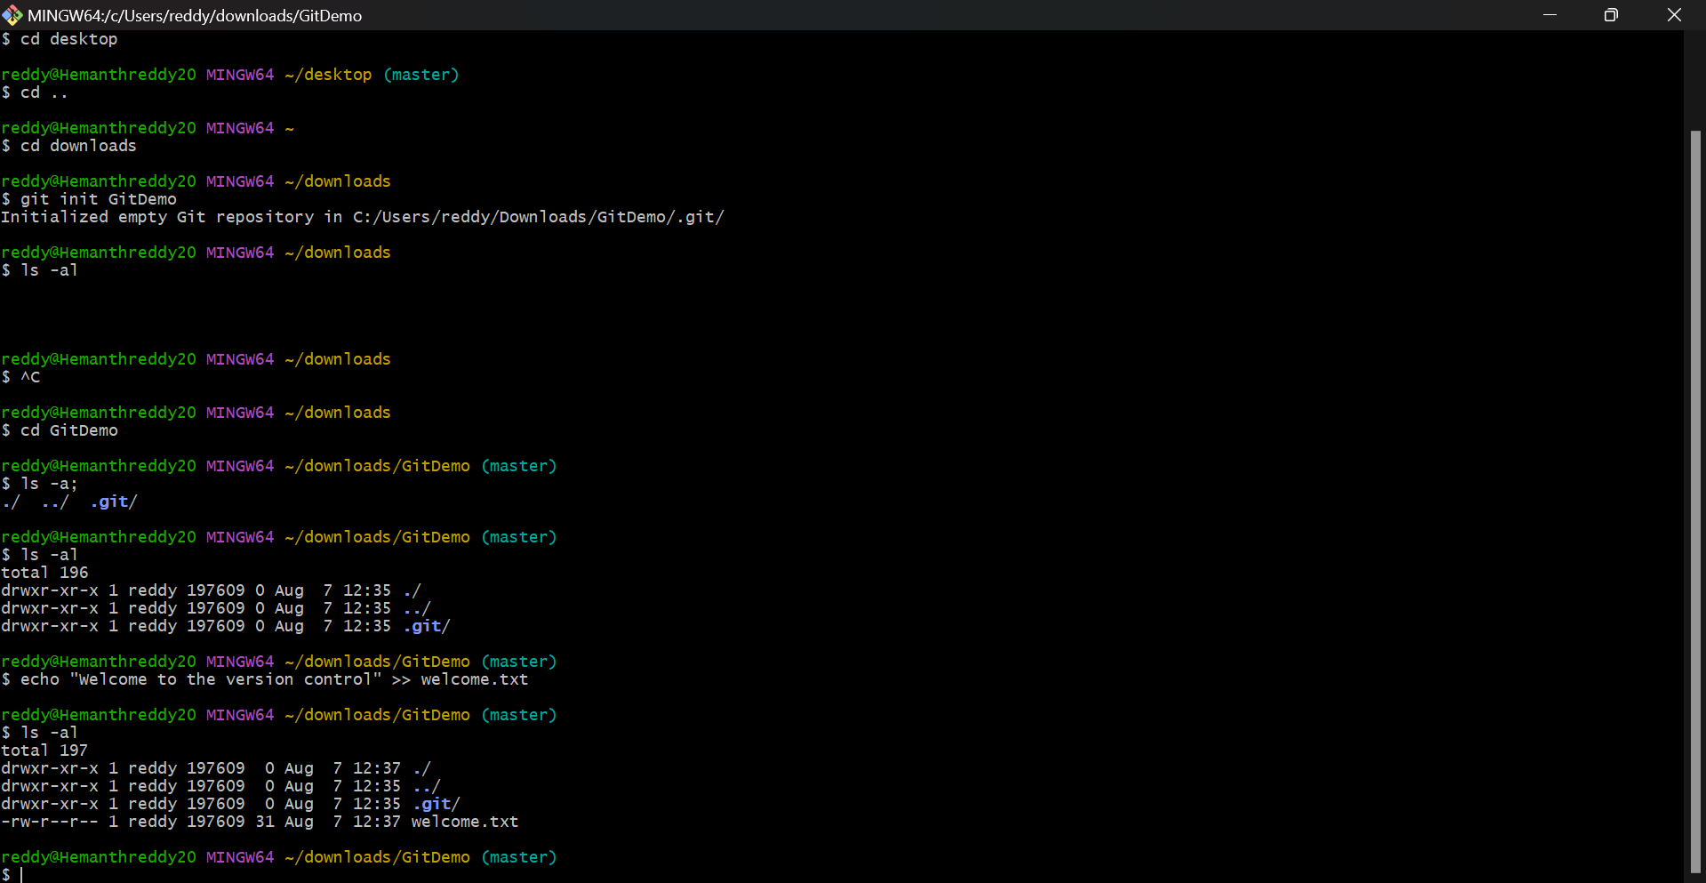

**2. Created a remote repository names as GitDemo in git lab and pushed a text file from GitDemo local repository and also pushed the same into Git Hub Digital_Nature_4.0_5672392 repository.**

